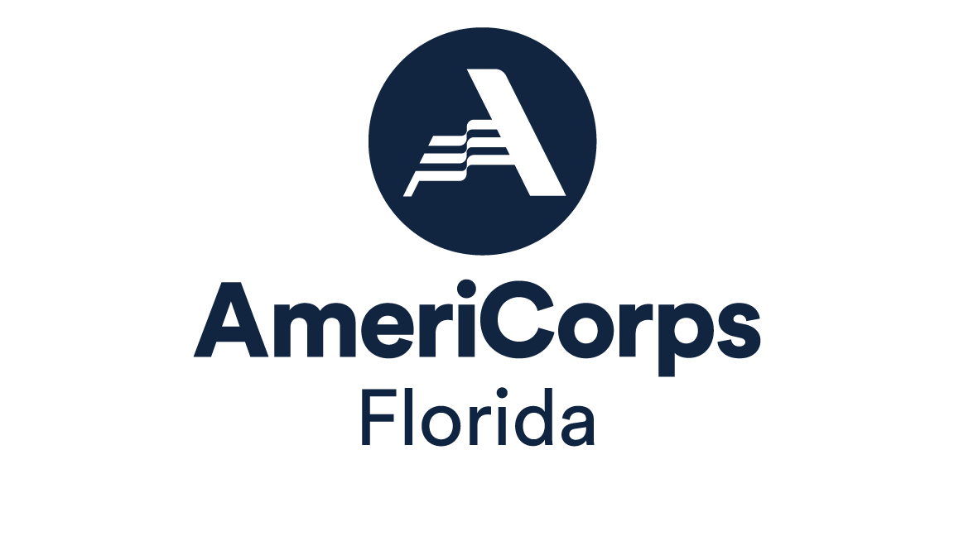

GENERAL ASSESSMENT QUESTIONNAIRE

This certification is to assure the Florida Commission on Community Service, that the contracted agency has adequate administrative procedures in place to ensure that funds disbursed by the Florida Commission on Community Service will be safeguarded as outlined in chapter 287, F.S. The Florida Commission on Community Service reserves the right to conduct on-site monitoring of contracted service providers as it deems necessary.

Please answer all questions by checking the applicable box. Please provide a brief explanation for any negative response.

- ORGANIZATION

1. Your organization has adequate staff resources to perform grant activities?
Yes No N/A
- Your agency’s accounting personnel have appropriate accounting,
education and experience? Yes No N/A

- SEGREGATION OF DUTIES

- Someone other than the timekeeper and persons who deliver paychecks
to employees prepares the payroll. Yes No N/A
- The duties of record keeper are separated from any cash
related functions. Yes No N/A
- Check signing is limited to those authorized to make disbursements and
whose duties exclude posting and recording of cash received. Yes No N/A
- Personnel performing the disbursement function are excluded from
purchasing, receiving, inventory, and general ledger functions. Yes No N/A
- Mail receipts are opened and listed by someone not involved in
posting, deposit preparation and deposit making. Yes No N/A
- The person making the deposit is different from the person who
prepares the deposit. Yes No N/A
- An official who is not responsible for its preparation and is outside
the payroll department approves the payroll. Yes No N/A

- POLICIES AND PROCEDURES

- Does your agency have policies and procedures related to the following?
Written policies and procedures address:
- Records retention Yes No N/A
- Travel and entertainment Yes No N/A
- Purchasing Yes No N/A
- Asset acquisitions, inventory, and disposal Yes No N/A
- Cash management (payables, receivables, deposits,
petty cash, reconciliation, etc.) Yes No N/A
- Credit cards Yes No N/A
- Subcontractors Yes No N/A
- Bad debt write-offs Yes No N/A
- Disaster recovery Yes No N/A
- Personnel Yes No N/A
- Employee loans Yes No N/A
- Client trust funds Yes No N/A
- Computer back-up Yes No N/A

- Policies and procedures are reviewed periodically and adjusted to
reflect current operations. Yes No N/A

III. INSURANCE

- The agency has comprehensive liability insurance. Yes No N/A
- Coverage is in effect. Yes No N/A

- CASH

- Cash Handling Procedures
- All revenue is deposited into one operating account. Yes No N/A
- Deposits are made timely. Yes No N/A
- The agency maintains a cash receipts journal. Yes No N/A
- Revenue received that is not deposited on the same day
is stored in a locked and secure location. Yes No N/A
- The person receiving the monthly bank statement in
the mail is the same person responsible for performing
the monthly account reconciliation. Yes No N/A
- Payments received in the mail are opened and logged by
someone not involved with posting or cash functions. Yes No N/A
- Checks received in the mail are restrictively endorsed
immediately upon opening the mail. Yes No N/A
- Cash received from fund raising events are properly
controlled, accounted, and reported. Yes No N/A
- Bank reconciliation is performed monthly, reviewed, and
signed by the next level of management. Yes No N/A

- Petty Cash
- A specific employee is designated, in writing as custodian. Yes No N/A
- Petty cash is not commingled with other funds and is
used for small, emergency expenses. Yes No N/A
- Cash fund is kept in a locked, secure location. Yes No N/A
- Payments are made through vouchers that are completely
and accurately filled out. Yes No N/A
- Petty cash payments are supported by invoices or receipts. Yes No N/A
- Petty cash payments made are under $50 (for small incidental purchases).
Yes No N/A
- Travel payments are not made from petty cash. Yes No N/A
- Documents are effectively canceled (marked paid) when
expense is paid. Yes No N/A
- Surprise audits are periodically performed and documented
in writing. Yes No N/A

V. ACCOUNTS RECEIVABLE

- A detailed accounts receivable aging schedule is maintained Yes No N/A
- The accounts receivable aging schedule is reconciled to the general
ledger monthly. Yes No N/A
- The agency has established accounts receivable write off procedures that:
- are properly documented in writing Yes No N/A
- are approved by the Exec. Director (and the Board of Directors Yes No N/A
as applicable)

- ASSETS AND PROPERTY

- An annual asset inventory is taken and recorded in writing. Yes No N/A
- Property records are reconciled to the general ledger at least annually. Yes No N/A
- Property/capital assets are recorded on an asset ledger with the following
information:
- Serial Number Yes No N/A
- Description Yes No N/A
- Purchase date and amount Yes No N/A
- Date disposed Yes No N/A
- Funding source Yes No N/A
- Condition Yes No N/A
- Location Yes No N/A
- Asset tag number (capital assets of $1000 or more) Yes No N/A
- Acquisitions and disposals are documented in writing. Yes No N/A
- Assets paid for by the Florida Commission on Community Service are
paid in full and are free from liens. Yes No N/A
- Assets paid for by the Florida Commission on Community Service were purchased prior to the
contract end date. Yes No N/A
- Leases for property and equipment are current and properly executed. Yes No N/A

- ACCOUNTS PAYABLE

- Disbursements
- The agency maintains an accounts payable ledger (checkbook)
for its operating account. Yes No N/A
- During the payment process, the following are verified by management:
- Checks are issued in sequence Yes No N/A
- Voids are clearly documented and accounted for Yes No N/A
- Multiple payments made to one payee during the
month are researched Yes No N/A
- Payments are based on original invoices Yes No N/A
- Payments are approved by appropriate management Yes No N/A
- Back-up is effectively canceled upon payment
(help prevent duplicate payments) Yes No N/A
- The check amount and invoice amount agree Yes No N/A
- Bills are timely paid Yes No N/A
- Payments to the Executive Director are countersigned
by a Board Member Yes No N/A
- Goods and services fall within the statute regarding
bidding are supported with a cost analysis price quotation or
competitive bid Yes No N/A

For tax exempt providers:
- Sales tax is not being paid on purchases of goods
or services Yes No N/A

- Employee Expense Transactions
- Expense reports/vouchers are utilized. Yes No N/A
- All expenses are supported with original receipts. Yes No N/A
- The business purpose of the expenses are clearly stated. Yes No N/A
- All conference expenses are supported with an agenda. Yes No N/A
- A mileage sheet or map mileage is used to calculate/reimburse
mileage. Yes No N/A
- The mileage sheet contains information to include beginning
and ending odometer readings, purpose, and destination. Yes No N/A
- All travel expenses reimbursed from state funding sources
are paid in accordance with state rates (s. 112.061, F.S.) Yes No N/A

- Credit Card Transactions
- The agency maintains a listing of who has credit cards and the
corresponding credit card numbers. Yes No N/A
- The agency performs monthly reconciliation of credit card
Statements and ensures that cardholders or designees do not use agency cards for personal purposes.
Yes No N/A
- The agency has review procedures to track and pay balances. Yes No N/A
- Corporate credit cards that are loaned to employees are controlled
through a log indicating the date, person’s name, purchase amount,
and description. Yes No N/A

- Tax Payments
- 941’s and Unemployment Compensation Tax are completed and submitted timely Yes No N/A
- Return of Funds
- Has the agency been required to return funds to the Commission on Community Service due to unallowable expenses? Yes No N/A

- PERSONNEL MANAGEMENT/PAYROLL

- All personnel files are up-to-date and contain position descriptions, required tax documents and performance evaluations. Yes No N/A
- All employees document their work hours through a time sheet or
punch clock; the employee and supervisor sign time records. Yes No N/A
- Non-exempt employees receive time and a half for all hours in excess of
40 per week. Yes No N/A
- Are any employees paid as independent contractors? If yes, please explain
in separate attachment. Yes No N/A

- SUBCONTRACTS/PROFESSIONAL AGREEMENTS

- All subcontracted services are supported through written agreements: Yes No N/A
- The agreement is signed by both parties. Yes No N/A
- The subcontract agreement indicates the scope of work
to be performed. Yes No N/A
Note: If any funds from the Florida Commission on Community Service are being used to pay sub contractors, the agency must receive prior approval from the Florida Commission on Community Service.

- FINANCIAL REPORTING

- Monthly financial statements are prepared and include at least:
- An income statement by cost center and grant Yes No N/A
- Balance sheet Yes No N/A
- Budget variance report Yes No N/A
- Support documentation for all journal entries made are retained. Yes No N/A
- The agency performs a monthly closing and prepares/prints a complete
set of accounting books (general ledger, accounts payable journal,
accounts receivable journal, etc.) Yes No N/A
- The agency maintains a current chart of accounts which:
- Allows for cost center and grant accounting Yes No N/A
- Tracks administration as a cost center and grant Yes No N/A
- Has a methodology to allocate indirect cost including admin Yes No N/A
- An independent audit has been performed.
(Funded programs will submit their audit reports to the Florida Commission on Community Service within 180 days from the agency’s fiscal year end). Yes No N/A
- The agency has an adequate record keeping system where records are
kept in a central location and appear to be neat and organized. Yes No N/A
- Agency management submits monthly financial statements to
the Board of Directors Yes No N/A
- The agency has an operating budget approved by the Board of Directors Yes No N/A
- In-kind transactions are reported in the general ledger for the grant. Yes No N/A

- FINANCIAL SYSTEMS
- The agency uses an accounting system software to monitor income
and expenditures Yes No N/A
2. Please provide the name of the accounting software: _____________________________

- ATTACHEMENT I CONDITIONS – METHOD OF PAYMENT (INVOICING)

Documentation supporting the number of units and dollars claimed on
corresponding invoices are kept by the agency and are available for review
and inspection. Yes No N/A

- LOBBYING

The agency has complied with s.216.347, F.S., which prohibits the use
of state contract funds for the purpose of lobbying the Legislature or
a state agency. Yes No N/A

DECLARATIONS – TO BE COMPLETED BY ALL PROVIDERS

- Please list any and all family relationships that exist between your board of directors, your agency’s principal officers, and your agency’s employees.

- Please provide a complete accounting of any and all transactions of business completed during the past twelve months between your agency and other entities or businesses owned or controlled by members of the Board of Directors.

- Please list any and all civil litigation pending against your agency. Include a statement as to the amount of each claim and whether such potential for loss is covered by insurance.

- Are any amounts or reports due to the Internal Revenue Service that have not been paid or filed? Specify amounts, reports, and due dates.

- Has there been any change in structure/operations of your programs? If yes, please describe in detail.

- Has staff turnover occurred in key positions? If yes, what are the affected positions and reasons for the turnover?

- Do you operate satellite sites? If so, how many locations? And is management of the satellite offices decentralized or centralized?

CERTIFICATION:

I hereby certify that the answers provided in this self-monitoring document are true and accurate to the best of my knowledge. I understand that falsification or misrepresentation on any question may be considered a breach of contract that may lead to the termination of all contracts with the Florida Commission on Community Service.

Signature – Executive Director Date

Name – Executive Director

Agency name and address:

Year Incorporated: _____________________________________________

Number of Years Receiving AmeriCorps Funds: __________________________

