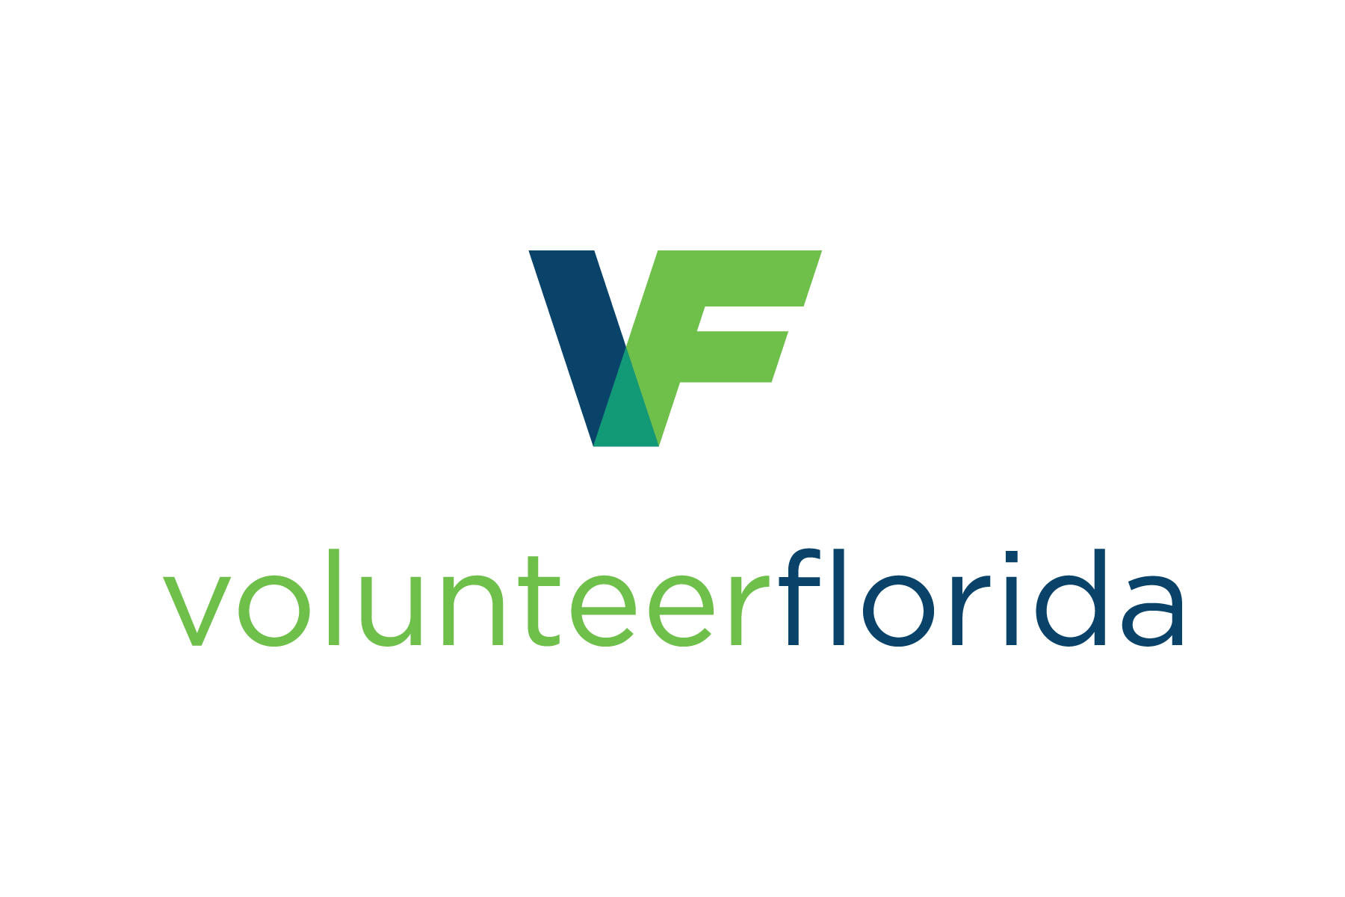

Endorsement by an Emergency Management Agency is not required for members in good standing of any Florida VOAD or COAD. If applicable, provide the name of the VOAD/COAD, a contact name and phone number or email below, then complete only the “Applying Organization” field in the endorsement form below.

VOAD/COAD name | Contact name | Phone or email

Florida Donations Portal Applicant Endorsement

I hereby endorse the organization named below for participation in the Florida Donations Portal. I understand that “participation” in the Portal means that the organization may be granted access to high value offers of goods donated to the State of Florida for disaster relief or other humanitarian purposes.

(Applicant: please type or print neatly)
Applying Organization
Applicant’s Representative
Organization Address (street/PO, city, state, zip)
Representative’s Phone Number
Representative’s Email Address

I have met with a representative of the organization and received the organization’s commitment to provide specific services as needed, and as the organization is able, in _________________County.

I am confident that any donated goods received by this organization through the Florida Donations Portal will be used in good faith for disaster relief or other humanitarian purposes, in accordance with the donor’s intentions.

I understand that the organization’s status as a 501(c)(3) not-for-profit organization will be verified by Volunteer Florida, lead agency for State ESF 15 Volunteers and Donations.

The authority to endorse (or not endorse) applicants for participation in the Florida Donations Portal has been granted by the emergency management agency of ________________ County. Endorsement of a relief organization does not make the endorsing agency or the county responsible in any way for any action/inaction of that relief organization. It merely acknowledges that the organization is known to county emergency management or the ESF 15 Coordinator and intends to provide disaster services in this county.

________________________________________________
Printed/typed Name

________________________________________________
Signature of Authorized Representative

________________________________________________
Authorized Organization

________________________________________________
Date


